Comparisons among Machine Learning Frameworks for Predicting High Bulk Modulus and DFT Validation of Inorganic Materials

Sabyasachi Roy ¹, Bhupratim Roy ², Md. Tanvir Ahmed ³

¹Department of Materials and Metallurgical Engineering, Bangladesh University of Engineering and Technology, Dhaka-1000, Bangladesh
²Department of Chemical Engineering, Bangladesh University of Engineering and Technology, Dhaka-1000, Bangladesh
³Department of Nuclear Engineering, University of Dhaka, Dhaka-1000, Bangladesh

E-mail: roysabyasachi6007@gmail.com , 1802048@che.buet.ac.bd , mta@du.ac.bd

ABSTRACT

This study sets a comparison among the machine learning frameworks: Random Forest, Support Vector Machine, Gradient Boosted Regressor, XGBoost, and CatBoost, in the case of predicting the bulk modulus of an inorganic material. For analysis, this study uses a curated materials dataset, which includes materials composition and crystal structures. The workflow uses the Pymatgen library for validation and data cleaning, and the feature engineering is done using Matminer’s Magpie compositional descriptors and density-based structural features, and then Hyperparameter is optimized. The SHAP shows that the valence potential average (VPA) impacts the most to predict the bulk modulus of a specific material for the tree-based ML algorithms: Random Forest, Gradient Boosted Regressor, XGBoost, and CatBoost. The considered ML models’ performance is evaluated through R² and MSE on a 70-15-15 train-validation-test split. Among the considered models, XGBoost achieves the highest R² of 0.9380 with the lowest computational cost. For validation, DFT calculations using GPAW are conducted by fitting the Birch–Murnaghan equation of state. The inorganic cubic BC₂N shows strong agreement between ML predictions (254–273 GPa) and DFT results (248 GPa). This approach demonstrates a cost-effective method for materials property prediction.

Keywords: Machine Learning; Bulk Modulus; Gradient Boosted Regressor; Random Forest; Support Vector Regression; XGBoost; CatBoost; Materials Property Prediction.

1. Introduction

One of the fundamental elastic characteristics of a substance that defines its ability to resist uniform compression and provides insight into the stability of the material, phase changes, and structure under pressure is the bulk modulus. The determination of bulk modulus is significant in most engineering applications, including the design of structural materials, optimization of manufacturing processes, and the interpretation of geophysical phenomena. The standard approaches to the calculation of bulk modulus include experimental or first-principles density functional theory calculations, either of which is a time and resource-consuming process on its own [1-3].
The techniques of machine learning have actually turned materials science into a field in whereby property predictions can now be rapidly made based on data-driven algorithms. Recent developments in materials informatics have demonstrated that machine learning algorithms have the potential to predict a wide range of various properties of materials with great precision and at low computational costs. The prediction of material properties has been particularly successful with the use of support vector regression, due to its ability to deal with high-dimensional feature spaces and nonlinear relationships. Besides this, a number of ensemble models, such as Random Forest, Gradient Boosting, XGBoost, and CatBoost, have also shown a very good performance in terms of the ability to capture complex structure-property relationships in materials systems [1,4-9]. Although numerous studies have explored material property prediction using various machine learning algorithms, there is still a lack of comprehensive comparative evaluation focusing on each algorithm’s fitting accuracy, how much time it requires to fit one model and deviation from the true experimental values [10-11,13].

Detailed materials databases and other advanced methods of featurization have all been used to hasten the adaptation of machine learning to materials science. The given libraries, pymatgen and matminer, can easily manage material data, feature extraction, and compute properties to convert complex crystal structures and compositions into machine-understandable descriptors. One of these, which is a high-quality approach to represent composition-based materials, is the Magpie descriptor set, consisting of elemental properties and structural ones [12-13].
This work aims to compare the holistic machine learning systems to predict bulk modulus, based on five optimized regression models, including Support Vector Regression, random forest, Gradient Boosted Regressor, XGBoost, and CatBoost, based on models’ efficiency and how close they are able to predict the property of a material. The materials validation was done using “pymatgen”, which is the advanced data preprocessing tool, and the advanced feature engineering was done using the featurization capability of matminer, and the rigorous hyperparameter optimization was done using grid search cross-validation. Predictive performance was checked against the high-fidelity density functional theory calculations performed using equation of state fitting with Grid-based Projected Augmented Wave, GPAW, to achieve accuracy and reliability. The work constitutes a major advance in computational materials science by offering a robust, efficient, and scalable methodology for the prediction of bulk moduli that can accelerate both the processes of discovery and design of materials.

2. METHODOLOGY

2.1 Dataset and Data Preprocessing

The dataset on the bulk modulus involved inorganic substances and associated bulk modulus values, their chemical compositions, and crystal structures. Additional pre-processing was also performed on the data with the Python Materials Genomics (Pymatgen) library to make sure that it attained a consistent and dependable computational workflow[1].
The preprocessing pipeline also involved many critical steps that were carried out to guarantee the quality of the data. Pandas was used to change the bulk modulus values to a numerical format with the error-handling features to support non-numeric values. Physical constraints were put in place by eliminating the entries that had a bulk modulus value of either zero or negative, since they do not have a physical meaning. Redundant entries were identified gradually and eliminated, keeping the polymorphic variants of the identical composition. The Pymatgen Composition class was used to verify chemical formulae by using invalid or malformed chemical formulae that could not be read by the formula.
Preprocessing of structural data consisted of parsing structure strings into Pymatgen Structure objects using a custom parsing function. This function determined lattice parameters (a, b, c, α, β, γ), atomic coordinates, and, where it was known, magnetic moments. Structures that were not processable were excluded in the dataset. Statistical analysis of the cleaned dataset was done in terms of the distribution of bulk modulus and element prevalence.
2.2 Feature Engineering

The Matminer library was used to perform the feature engineering using two broad kinds of descriptors, namely compositional and structural features. In compositional features, the ElementProperty featurizer is applied with the Magpie preset, which codes essential chemical data that takes into account the atomic radii, electronegativity, ionization energies, electron configuration, and a host of other atomic properties. This gives a sum of 132 compositional features to define the underlying chemistry of the materials.
The DensityFeatures featurizer developed by Matminer was used to obtain structural features through the calculation of material density and packing efficiency on the basis of crystal structure data. These structural descriptors give geometric information that is complementary to compositional features vital in the estimation of mechanical properties.
The generation of missing values created in the process of featurization was filled with the SimpleImputer of scikit-learn, which was configured with a mean imputation strategy. This guarantees that every feature is full but it still represents statistical characteristics of the original data distribution. The last feature matrix contained both compositional and structural descriptors and, therefore, offered the appropriate representation of the properties of each material.

2.3 Machine Learning Models and Implementation

Various state-of-the-art regression algorithms were used to forecast bulk modulus. These are Random Forest Regressor, Support Vector Regression, Gradient Boosted Regressor, XGBoost Regressor and CatBoost Regressor. All the algorithms were chosen based on their effectiveness in materials science tasks and the ability to approximate the nonlinear correlation between features and target properties [4-5].
The systematic division of the data into the training, validation, and test sets was based on the 70-15-15 split so that an adequate assessment of the model is possible. Because of the risk of an unbalanced distribution of bulk modulus values, we will apply the log transformation of the target variable log(1+y) to deal with the zero values. StandardScaler of scikit-learn is used to scale features, which are fitted to the training data only to prevent data leakage.

2.4 Hyperparameter Optimization

In this regard, hyperparameter optimization was performed using the GridSearchCV algorithm with five-fold cross-validation to guarantee sound, unbiased, and consistent model selection. As can be imagined, this methodically examined all the possible combinations of hyperparameters of each regression model and found the configuration that reduces the prediction error as much as possible without compromising the high generalization ability of the model. The method employed to assess the evaluation is the negative mean squared error (-MSE) as it penalizes big deviations between predictions and actual prices, therefore fitting it to continuous property prediction applications like material property forecasting.
The regression algorithms optimized in this study were RF, SVR, GBR, XGBoost, and CBR. This gave a total of five optimum models. The hyperparameter search space was also optimally chosen relative to each algorithm, to achieve a balance between the computational feasibility and the model flexibility and predictive performance.

- Random Forest (RF):

For the Random Forest algorithm, the grid search was conducted with variations in essential parameters like the number of trees, or n_estimators = [100, 200, 300], a maximum depth of each tree, or max_depth = [10, 20, None], and minimum samples required to split a node, or min_samples_split = [2, 5, 10]. These parameters regulate the size and complexity of the trees, which helps in controlling the bias-variance tradeoff. This results in a total of 12 distinctive combinations that were assessed for the Random Forest model.

- Support Vector Regression (SVR):

For SVR, the most impactful hyperparameters optimized were kernel type (kernel = ['rbf']), the regularization parameter C = [1, 10, 100], epsilon-insensitive loss ε = [0.1, 0.2], and the kernel coefficient gamma = ['scale', 'auto']. The choice of the RBF kernel ensures that any nonlinear patterns in most materials datasets are duly captured. In all, 12 SVR model variations were tried for optimization.

- Gradient Boosted Regressor (GBR):

The GBR optimization process explored combinations of n_estimators = [100, 200], max_depth = [3, 5, 7], learning_rate = [0.01, 0.1], and min_samples_split = [2, 5]. These parameters control how individual weak learners (trees) contribute to the ensemble, with implications on both model speed and predictive accuracy. A total of 24 different GBR models were trained and evaluated via cross-validation.

- Extreme Gradient Boosting (XGBoost):

For XGBoost, a more granular parameter grid was implemented with n_estimators = [100, 200], max_depth = [3, 6, 9], learning_rate = [0.01, 0.1], min_child_weight = [1, 3, 5], and subsample = [0.8, 1.0]. These hyperparameters jointly control regularization, tree growth, and sample randomness for finer means of controlling overfitting. In all, 36 different XGBoost model configurations were considered to identify the best combination.

- CatBoost Regressor (CBR):

The CatBoost optimization tested variations in iterations = [500, 1000], depth = [4, 6, 8], learning_rate = [0.01, 0.1], l2_leaf_reg = [1, 3, 5], and subsample = [0.8, 1.0]. CatBoost's ordered boosting and built-in regularization mechanisms inherently reduce overfitting and make it efficient for datasets with nonlinear feature interactions. A total of 36 combinations of hyperparameters were evaluated for the CatBoost model.

The time taken per training in the grid search process was used in the evaluation of the computational performance of the process, as it involved the model fitting, cross-validation, and scoring procedures. This made it easy to compare the cost of computation versus the accuracy of the various models, and this points to the trade-off between quality and cost efficiency in predictions.

Lastly, cross-validation was used to pick the best hyperparameter sets of all five algorithms. The best configurations came up with the five best models that together gave a strong and efficient predictive model of material property regression. This strict optimization made sure that every model attained maximum predictive accuracy, strong generalization, and efficient calculation, and this proposed framework was applicable to practical use in material informatics.

2.5 SHAP Analysis

Shapely Additive exPlanations (SHAP) analysis is used to provide more interpretability to understand the output of Machine Learning Algorithms. SHAP analysis shows which features increase or decrease and how much they contributed to complete the expected prediction process. For tree-based ML algorithms, SHAP analysis is more likely to be provided to show how the data is split into branches. SHAP analysis traces these splits and provides a mathematical reasoning of each feature’s contribution to predict the outcome [14].
In this study, SHAP analysis has been conducted using the Python library shap, and only for the tree-based ML algorithms, which are considered here they are RF, CatBoost, XGBoost, and GBR. For the analysis, the features that are used to predict the “bulk modulus” are taken into consideration.
Additionally, this study uses 132 compositional features to train the ML model and generate the final results. Presenting the contribution of all these features would make the analysis difficult to interpret. Therefore, only the top five features with the strongest influence on predicting the material properties are shown in the results section.

2.6 Model Evaluation and Validation

The models were evaluated based on their performance using different measurements, including RMSE and the coefficient of determination (R²). The inverse log transformation was used to transform all the predictions back to the original scale. Deviation plots were generated to display physical disparities between anticipated and precise values, hence obtaining an understanding of the model's precision at various bulk modulus ranges.

2.7 DFT Validation Using GPAW

A set of materials was validated with a density functional theory to verify the reliability and physical accuracy of the machine learning predictions through the use of the GPAW code. DFT validation protocol work included several systematized steps:

Electronic Structure Calculations: The GPAW calculations utilized the projector-augmented wave (PAW) method with a plane-wave basis set. The simulations employed a plane-wave cutoff energy of 500 eV, k-point grids of 10 × 10 × 10, and the PBE exchange-correlation functional.

Equation of State Fitting: The Bulk modulus is computed by fitting the Birch-Murnaghan equation of state to energy-volume data, given in Equation 1. The EOS fitting approach followed here calculates the total energy for a range of isotropically scaled unit cells, typically covering volume changes of ±6% around the equilibrium volume with 4 data points.

Validation Methodology: Bulk modulus values computed by using DFT provided reference benchmarks for comparisons against the machine learning predictions. Deviations between ML predictions and DFT calculations, quantified as percentage errors, provided a physics-based validation of model accuracy.

The GPAW implementation utilized the Atomic Simulation Environment (ASE) for structure manipulation and interfacing to the DFT calculations. Convergence criteria for the total energy were chosen so that the calculations were reliable; specifically, the electronic self-consistency tolerance was 10⁻⁴ eV, with force convergence criteria at 0.05 eV/Å when structural relaxations were performed.

This is a comprehensive methodology in that it not only provides statistical rigour by way of systematic hyperparameter optimization and cross-validation but also physical by way of comparison with first-principles DFT calculations, which arguably forms a solid foundation on which prediction of bulk modulus by using machine learning methods can be made. Fig. 1 schematically depicts the workflow of the study. The program to perform computations in this study was run on the NVIDIA Tesla K80 computing device, the default computing device in the Google Colab cloud computing model.

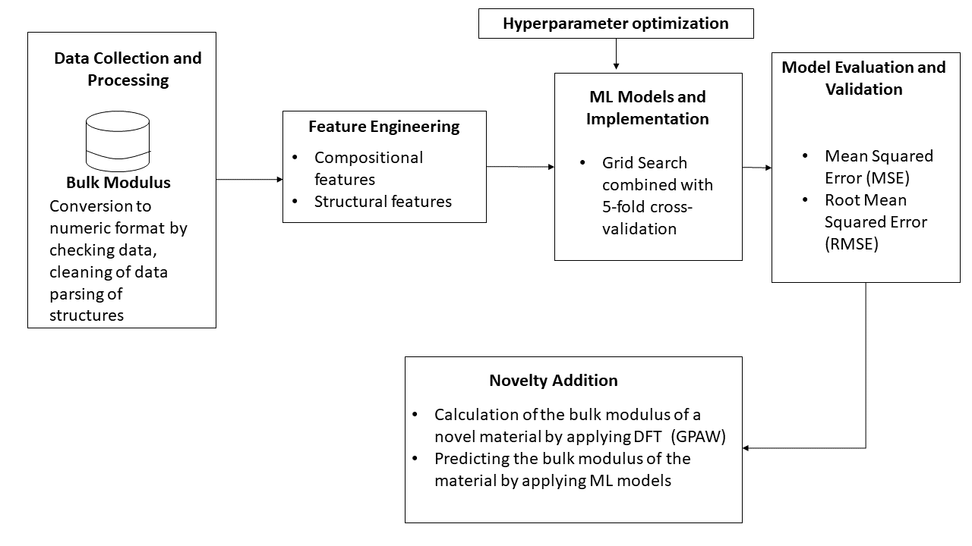
Fig. 1: The workflow

3. Result and Discussion

3.1 Equation of state

The third-order Birch-Murnaghan isothermal equation of state is given by [15],
$$\begin{aligned}P\left(V\right)=\frac{3B_{0}}{2}\left[{\left(\frac{V_{0}}{V}\right)}^{\frac{7}{3}}-{\left(\frac{V_{0}}{V}\right)}^{\frac{5}{3}}\right]\left\{1+\frac{3}{4}\left(B_{0}^{'}-4\right)\left[{\left(\frac{V_{0}}{V}\right)}^{\frac{2}{3}}-1\right]\right\} \#\left(1\right)\end{aligned}$$

Where P is the pressure, $V_{0}$is the reference volume, V is the deformed volume, $B_{0}$ is the bulk modulus, and $B_{0}^{'}$ is the derivative of the bulk modulus with respect to pressure.

3.2 SHAP Analysis Outcome

Fig.2 -5 depicts that which features of the materials are contributed the most to predict the value of bulk modulus. The figures show that VPA (the abbreviations are given at the end of the manuscript) has the highest contribution for each model to predict the bulk modulus of the material. The right portion of vertical line shows that the value of bulk modulus increases with the value of feature value increases and the left portion of the vertical line shows that the value of bulk modulus decreases with the value of feature value decreases. The more it goes far from the vertical zero line, the more it makes impactful decision on prediction. It is expected that VPA would have the greatest contribution in bulk modulus prediction. Since high value of VPA refers to high electronic bond, which refers to high value to bulk modulus [16]. For each model, the features with notable contribution differs, that is the reason why each model takes a different amount of time to train with the data and provides different predicted values of materials.

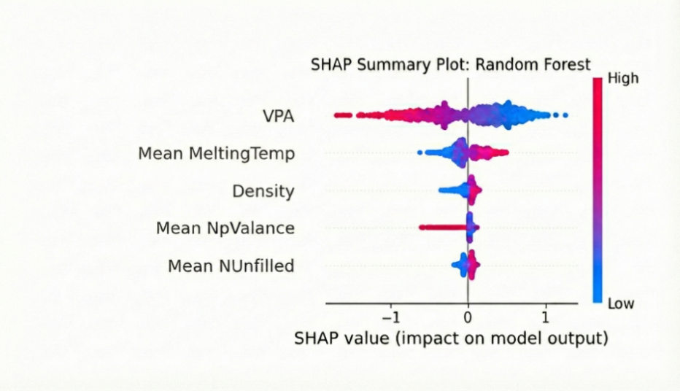

Fig. 2: SHAP analysis for Random Forest

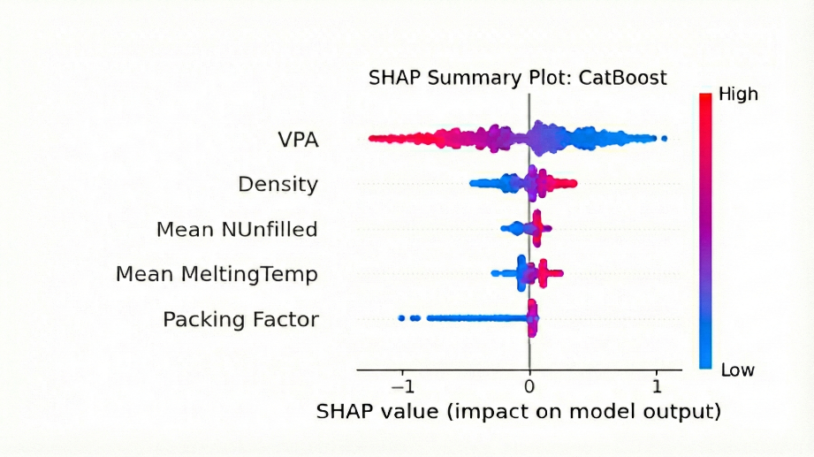
Fig. 3: SHAP analysis for CatBoost

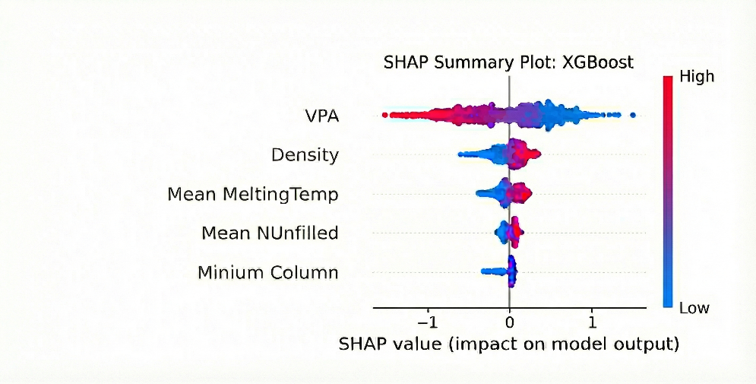
Fig. 4: SHAP analysis for XGBoost

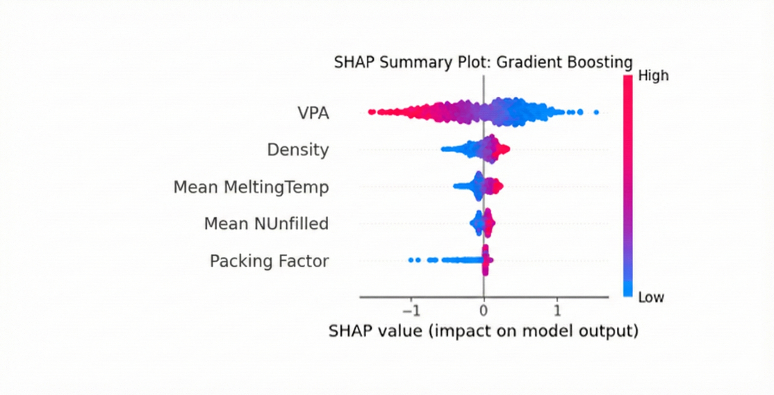

Fig. 5: SHAP analysis for Gradient Boosting Regressor

  - Comparative analysis among ML algorithms

An overview of the machine learning algorithms is compared and assessed in Table 1 and demonstrated in Fig. 2 and Fig. 3. All the models have high predictive power with a coefficient of determination (R²) of over 0.92, proving their relevance in predicting the bulk modulus accurately. XGBoost was the most accurate one (R² = 0.9380) and the most cost-effective (1.6378 s per fit) model, which simultaneously demonstrates its efficiency and scalability to large data sets. Gradient Boosting Regressor (GBR) and Random Forest (RF) models were also found to be equally accurate (R² = 0.9374 and 0.9360, respectively), but with much longer computation time (76.7252 s per fit) for RF. CatBoost was found to have a moderate accuracy (R² = 0.9325) with efficient training time (2.1561 s), and Support Vector Regressor (SVR) had R² = 0.9298 with an acceptable fitting time of 7.0957 s and provides a good trade-off between accuracy and cost to train.

These findings are further supported by the Root Mean Square Error (RMSE) Comparison in Figure 1, which indicates that all algorithms have a close range of prediction errors in the range of 18-20GPa. XGBoost and GBR models resulted in the lowest RMSE value, indicating their better generalization ability as compared to SVR and CatBoost, which were slightly higher in error margin. All these findings support the fact that ensemble-based algorithms, especially the XGBoost, can provide strong and dependable forecasts in intricate material property estimation problems.

Fig. 3 shows the parity plot of all machine learning models when compared with predicted and actual bulk modulus values. Bulk modulus (GPa) is plotted on the x-axis, and the prediction of each model on the y-axis. The colored points indicate each algorithm, and the dashed black line indicates the ideal parity line (y = x) that denotes the perfect prediction. Most of the data points follow this line, indicating that there is a high agreement between the predicted and actual values of all the models. Also, the figure shows a more accurate correspondence to the ideal line when the bulk modulus values are high, and this implies that materials with bulk moduli near 150 GPa and above can be successfully modeled with the proposed ML frameworks with a deviation of about ±18–20 GPa.

Ensemble learning models XGBoost, GBR, and CatBoost have the greatest predictive consistency, with their predictions being tightly clustered about the parity line with few scattered points. In contrast, SVR shows slightly larger deviations at higher modulus values, indicating minor limitations in capturing extreme data behavior. Overall, the dense clustering of points along the ideal parity line confirms the models’ capability to effectively learn and generalize the underlying structure–property relationships, ensuring reliable prediction of bulk modulus for materials.
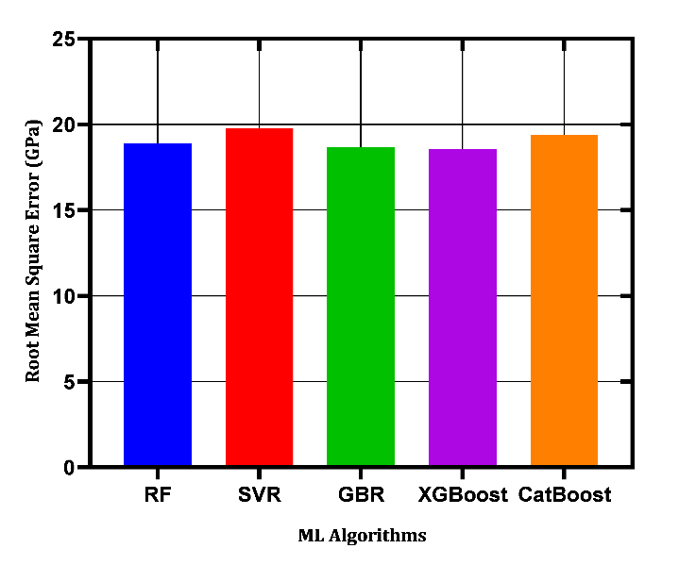

Fig. 6: Comparison among the ML algorithms based on root mean squared error (RMSE).

.

Table 1: Comparison among ML algorithms based on R² value and time required to fit one model.

ML algorithms | R² Value | Time required to fit one model  (seconds)
RF | 0.9360 | 76.7252
SVR | 0.9298 | 7.0957
GBR | 0.9374 | 32.8128
XGBoost | 0.9380 | 1.6378
CatBoost | 0.9325 | 2.1561

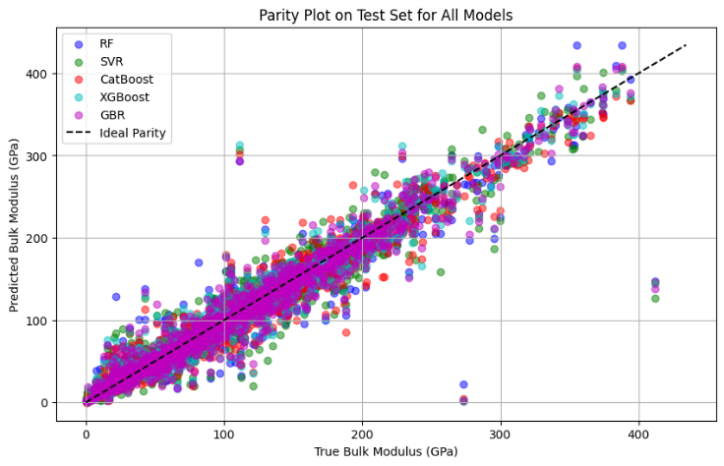
Fig. 7: The deviation from the ideal prediction of the data that is used to train the ML models

  - DFT analysis

The study computed the energy–volume relationship for the proposed cubic BC₂N (primitive P-43m, 4 atoms/cell) using plane-wave DFT (PBE) and fitted the resulting points to the Birch–Murnaghan equation of state. The fit yields an equilibrium cell volume of V₀​=32.263 Å³ (≈ 8.07 Å⁰ per atom) and an equilibrium total energy of E₀=−31.735eV per cell (≈ −7.93 eV per atom). The extracted bulk modulus is B≈248 GPa, indicating that this BC₂N polymorph is mechanically stiff and a promising candidate for applications requiring high incompressibility. The obtained result is provided in Fig. 4.
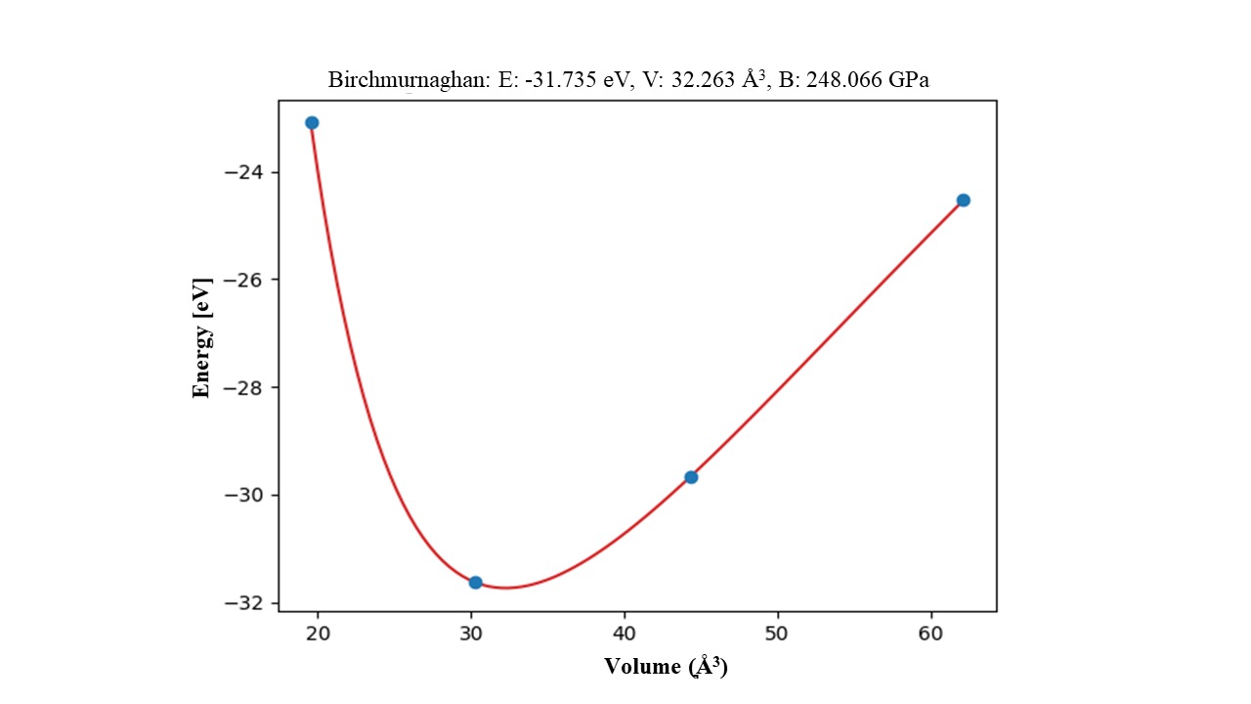
Fig. 4: Energy vs. volume curve for the proposed cubic BC₂N

  - Bulk modulus prediction using the ML algorithms

Table 2 presents the results of the predicted bulk modulus for the proposed materials.

Table 2: Prediction of bulk modulus of the proposed material using ML algorithms

Model Name | Predicted Bulk Modulus using ML algorithms  (GPa) | Calculated Bulk Modulus using DFT (GPa)
RF | 273.33 | 248.066
SVR | 254.12
GBR | 260.14
XGBoost | 273.27
CatBoost | 269.39

The DFT-calculated bulk modulus of 248.07 GPa shows good agreement with the machine learning predictions, which range from 254.12 GPa to 273.33 GPa. Among these, the SVR model exhibited the closest match, differing by less than 3% from the DFT result. This consistency between data-driven and first-principles approaches strengthens the reliability of the predicted mechanical behavior of BC₂N and indicates that the trained ML models are capable of accurately estimating the bulk modulus for BC₂N compounds.
The slightly higher ML-predicted values may be attributed to differences in the training dataset compositions, which could include materials with higher bonding strengths or differing stoichiometries.

4. CONCLUSION

This work has developed and validated a robust machine learning pipeline for bulk modulus prediction (materials with high bulk modulus), demonstrating the efficacy of ensemble-based algorithms in capturing complex structure-property relationships in inorganic materials. This study reveals that among the features of materials, the valence potential average impacts the most in case of predicting the bulk modulus of any material. The optimized models: RF, SVR, GBR, XGBoost, and CatBoost, exhibited high predictive performance, with R² values exceeding 0.92 and RMSE around 18–20 GPa, underscoring their suitability for practical applications in materials science. XGBoost emerged as the standout performer, balancing superior accuracy with computational efficiency, making it ideal for large-scale screenings. The close agreement between ML predictions and DFT-calculated values for BC₂N underscores the framework's physical reliability and potential to complement or reduce the need for resource-intensive first-principles simulations in predicting the bulk modulus of materials with higher values. By integrating advanced featurization techniques and systematic validation, this methodology paves the way for accelerated materials discovery, enabling faster optimization of mechanical properties for engineering, geophysical, and high-pressure applications. The purpose of the study to find out which ML models can more efficiently and effectively predict the materials' properties, and which feature among the materials dataset contributes the most to this prediction. Future extensions could incorporate larger datasets, additional descriptors, or multi-property predictions to further enhance predictive capabilities in computational materials design.

Abbreviations:

Short Form | Full Form
RF | Random Forest
SVR | Support Vector Regressor
GBR | Gradient Boosted Regressor
VPA | Valence Potential Average
Mean MeltingTemp | Mean melting temperature of the elements in the material
Mean NUnfilled | Mean number of unfilled electron orbitals of the elements in the material
Mean NpValence | Mean number of p-valence electrons across all the elements in the material
Minimum Column | Minimum periodic table column number of the elements in the material
Density | Density of the material
Packing Factor | Atomic Packing Factor

References

[1] M. Kandavalli, A. Agarwal, and A. Poonia, “Design of high bulk moduli high entropy alloys using machine learning,” Sci. Rep., vol. 13, p. 20504, 2023
[2] K. Choudhary, G. Cheon, E. Reed, and F. Tavazza, “Elastic properties of bulk and low-dimensional materials using Van der Waals density functional,” Phys. Rev. B, vol. 98, no. 1, p. 014107, 2018.

[3] K. Latimer, S. Dwaraknath, K. Mathew et al., “Evaluation of thermodynamic equations of state across chemistry and structure in the materials project,” npj Comput. Mater., vol. 4, p. 40, 2018.

[4] M. Lee, M. Kim, and K. Min, “Evaluation of principal features for predicting bulk and shear modulus of inorganic solids with machine learning,” Mater. Today Commun., vol. 33, p. 104208, 2022.

[5] P.-P. De Breuck, G. Hautier, and G.-M. Rignanese, “Materials property prediction for limited datasets enabled by feature selection and joint learning with MODNet,” npj Comput. Mater., vol. 7, p. 83, 2021.

[6] Awad, Mariette, and Rahul Khanna. "Support vector regression." In Efficient learning machines: Theories, concepts, and applications for engineers and system designers, pp. 67-80. Berkeley, CA: Apress, 2015.

[7] I. Malashin, V. Tynchenko, A. Gantimurov, V. Nelyub, and A. Borodulin, “Boosting-Based Machine Learning Applications in Polymer Science: A Review,” Polymers, vol. 17, no. 4, p. 499, 2025.

[8] T. Nguyen-Sy, “Optimized hybrid XGBoost-CatBoost model for enhanced prediction of concrete strength and reliability analysis using Monte Carlo simulations,” Appl. Soft Comput., vol. 167, pt. C, p. 112490, 2024.

[9] M. V. Vasić, P. O. Awoyera, O. G. Fadugba et al., “Advanced machine learning models for the prediction of ceramic tiles’ properties during the firing stage,” Sci. Rep., vol. 15, p. 31397, 2025.

[10] A. Allen and A. Tkatchenko. "Machine learning of material properties: Predictive and interpretable multilinear models." Science Advances, 8 (2022). https://doi.org/10.1126/sciadv.abm7185.

[11] Kai Guo, Zhenze Yang, Chi-Hua Yu and M. Buehler. "Artificial intelligence and machine learning in design of mechanical materials.." Materials horizons, 8 4 (2021): 1153-1172 . https://doi.org/10.1039/d0mh01451f.

[12] L. Ward, A. Dunn, A. Faghaninia, N. E. R. Zimmermann, S. Bajaj, Q. Wang, J. Montoya, J. Chen, K. Bystrom, M. Dylla, K. Chard, M. Asta, K. A. Persson, G. J. Snyder, I. Foster, and A. Jain, “Matminer: An open source toolkit for materials data mining,” Comput. Mater. Sci., vol. 152, pp. 60-69, 2018.

[13] Yue Liu, Tianlu Zhao, Wangwei Ju and S. Shi. "Materials discovery and design using machine learning." Journal of Materiomics, 3 (2017): 159-177.

[14] Mosca, Edoardo, Ferenc Szigeti, Stella Tragianni, Daniel Gallagher, and Georg Groh. "SHAP-based explanation methods: a review for NLP interpretability." In Proceedings of the 29th international conference on computational linguistics, pp. 4593-4603. 2022.

[15] Gilvarry, J. J. "Temperature‐dependent equations of state of solids." Journal of applied physics 28, no. 11 (1957): 1253-1261.

[16] Bo Xu, Qianqian Wang and Yongjun Tian. "Bulk modulus for polar covalent crystals." Scientific Reports, 3 (2013). https://doi.org/10.1038/srep03068.

